## <h4>About ApTest </h4>

ApTest Manager is an application designed for providing testing and analysis over the internet for projects in development. </p>

This manager uses ‘Suites’ which are a collection of ‘Test Cases’ (individual procedures for testing functionality) and each ‘Suite’ usually represents a different project in development.</p>

‘Test Cases’ in these ‘Suites’ can be organised into folders and folder hierarchies known as ‘Scripts’ which are intended to test different aspects and areas of the project. </p>

You can select these ‘Test Cases’ and run them to test functions and features of the project, by doing so you create a ‘Test Session’ which is a collection of ‘Test Cases’ that have been selected to run. This ‘Test Session’ allows testers to mark when ‘Test Cases’ pass, fail or can’t be started, how long these tests take, report bugs and make notes about individual tests. </p>

The ‘Test Session’ can also show the percentage of completed tests, how many pass and fail, any notes and bug reported for the test as well as the expected time and actual time for completing the ‘Test Session’. This useful for Team Leads to monitor testing and ensure that targets and deadlines are being met. </p>

## <h4>Navigating ApTest: </h4>

<img src=“images/aptest_menu.jpg” />

Aptest main toolbar.jpg

These are the five buttons used for navigating through ApTest. They are in the top-right corner of the window. </p>

<ul>

**<li> <b>Tests</b>** – Takes you to the window that displays the ‘Test Cases’. This contains a panel on the left showing the ‘Script’ hierarchy and the panel on the right displaying folders and ‘Test Cases’. This is where you import, edit and run individual Test Cases. </li>

**<li><b>Run</b>** – Here you can view ‘Test Sessions’ that have been created. Here you can run and edit ‘Test Sessions’</li>

**<li><b>Reports</b>** – Here reports can be generated using ‘Test Sessions’. For team leads.</li>

**<li><b>Manage </b>**– Here are the setting for the suite. Only an admin can edit these.</li>

**<li><b>Suites</b>** – Here you can select different ‘Suites’ to run tests in.</li>

**<li><b>Help on </b>**– This button load a help bar on the right of the screen.</li>

</ul>

## <h4>Importing into ApTest:</h4>

C:\Users\mread\Pictures\cheat sheet\Top Menu.PNG

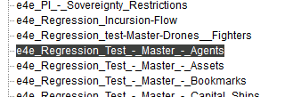

Ensure that all commas are removed from the “Test Procedure” and “Verification” columns of Excel spreadsheet before saving as a CSV file. If these are not removed this can cause Test Cases to have sub-steps. </p>

Make sure the “Test Case” titles are of the format “xxx [Script name]” where xxx represents the test number in a three digit format e.g. 001, 022, 333 etc.</p>

When importing only one ‘Feature’ can be entered into the ‘Feature’ field of the spreadsheet, if other features are associated with ‘Test Case’ they should be added to ApTest manually. .</p>

If you are importing a Script into a folder that already contains a previous version of the Script it is best to delete the previous version and import the new one. .</p>

## <h4>Running Tests:</h4>

### <b>Starting a ‘Test Session’:</b></p>

First you need to navigate to the script selection screen, by clicking on the “TESTS” link in the top menu. </p>

<img src=“images/aptest_menu.jpg” class= “contentimage”/>

Once on that screen, select the script you want to run from the list on the left. </p>

Some of these might have subfolders (Incursions, PI, Customs, etc) </p>

The test cases of that script should now be listed in the right panel. </p>

Using the tick boxes, you can choose individual test cases to run or select the tick box at the top to run all of them. </p>

Once you have selected the desired test cases, select “Run these tests” from the Action Drop-down Menu and click “Go”. </p>

You should then be brought to the “Run Session” page, where you must name your session for ease of recognition (you’ll need to, there are hundreds of sessions). The convention to be adopted is “[Task] – [ScriptName]” (for reviewing use “[ScriptName] – Review”). Comments are not necessary. </p>

Lower on the same page you shall be asked how you wish to run the script. </p>

You can run the test cases one at a time, although many at a time will allow you to plan ahead. </p>

Once you have selected one of these options, click “Manage Session”. </p>

c) Assigning Test Cases

The fastest way to assign a script to yourself is to tick the top box just under Select, to select all test cases, then find your name/username in the “Assigned To” list and click on it.

Click “RUN” in the top menu to be taken to the list of sessions, which should be displayed similarly to the following:

Your session should now be easily identifiable, with all the information you inputted: Name, Assignee, Server, Release, Branch, and Build.

To run the session, click on the little arrow next to the tick box.

On the following screen, you can select how you want the tests to be presented, and which ones you want to run.

Ticking “Run just tests assigned to you” can make things easier if several testers are working on one same session.

Once your settings are selected, click the “Run Tests” button.

That’s all there is to it!

### <h4>Completing ‘Test Cases’:</h4>

When you have completed a Test Case you must mark the result of the test using the ‘Result’ drop down menu. You will mark it as one of the following:</p>

<ul>

<li>Untested – This feature was not tested.</li>

<li>Pass - The test was successful and completed without any defects</li>

<li>Blocked – This test could not be started either due to a missing precondition or inability to access the feature for testing. </li>

<li>Invalid – This test is no longer valid and requires alteration</li>

<li>Fail – The test fails due to defect in the feature. </li>

<li>Incomplete – This test was started but not completed. </li>

</ul>

You must also mark down the time taken to complete this test, please be as accurate as possible.</p>

If you have a test that contains some wait time (time need for certain features to activate) you should set the Test Case to Incomplete and move onto the next one if possible. If you cannot continue till the wait time is completed then start a different test and come back to this one later (see ‘Resuming Tests’). </p>

**<u><b>Note: Wait Times are not to be recorded in ApTest, only time spent actually doing the test steps should be recorded.</b></u></p>**

If a test only contains a ‘Precondition and Setup’ but no ‘Test Procedure’ or ‘Verification’ then simply complete the steps mentioned in the Precondition and mark the Test as a pass.</p>

If you find any problems or errors in the Test Case and do not have access to a Change log for the Script then make a note in the ‘Execution Notes’ for the case and continue the tests. If a defect is found when completing a ‘Test Case’ then report by your usual procedures, when you receive the defect number add it to the execution notes.</p>

## <h4>Resuming Tests:</h4>

If for any reason you have to close the Test window (e.g. restarting PC, internet busted etc) then you can resume a test by clicking the ‘Run’ button from the toolbar in the top-right of the screen, this will load a page listing all of the Test Sessions created. Scroll through the list until you find the Test Session with the name you gave it earlier. To the left of the name you will see three buttons that look like this:</p>

Aptest Run toolbar.jpg

These buttons are the ‘Run Session’, ‘Session Summary’ and ‘Manage Session’ in that order. </p>

Click the ‘Run Session’ button to launch a pop-up. This pop-up will list the different test states as well as the number of test cases with that status. Select the status of test you want to run. So if you want to continue from where you left off then select ‘untested’, if you want to retest failed tests then select ‘fail’ etc. You also have the option at the top to run the test cases one at a time or many at a time, you will usually want to do many at a time. </p>

<img src=“aptest_run” class= “contentimage”/>

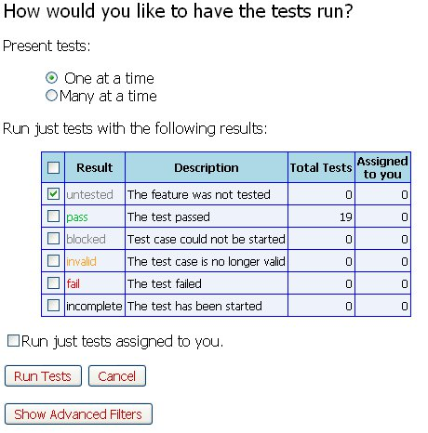

After selecting the tests you can click ‘Run Tests’ and it should start the test session using only those you have selected. </p>

## <h4>Appending Tests:</h4>

To add defect numbers and execution notes you can click the ‘Session Summary’ button mentioned previously. This will launch a pop-up displaying information about test completion, time taken etc. </p>

There is a table named ‘Result Details’ which will display the ‘Test Cases’ as individual rows, each displaying the results and notes for the test case. Select the [Edit Note] in the right most column of the table; this will launch another pop-up into which you can enter the defect number/note.